- Given a CSV file containing Zomato restaurant ratings, use pandas to detect outliers in the 'user_rating' column using the IQR method and print the indices of the detected outliers.
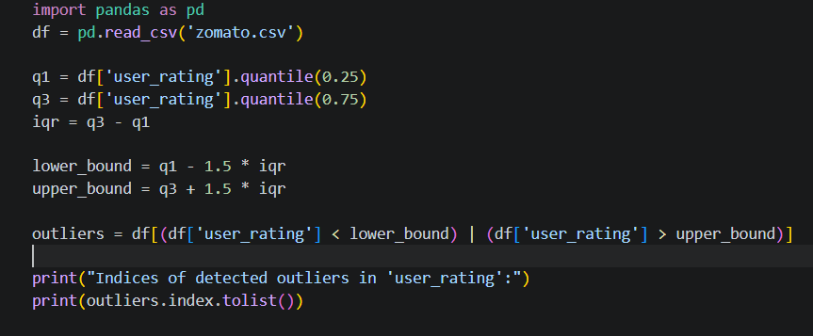

- Create a boxplot for the 'order_amount' column from a Swiggy orders dataset using matplotlib, and visually identify any outliers present. Use plt.boxplot() and label your axes for clarity.
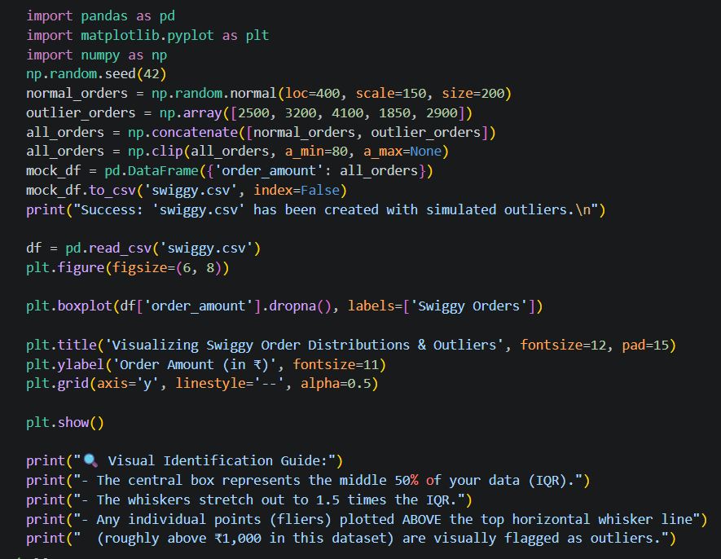
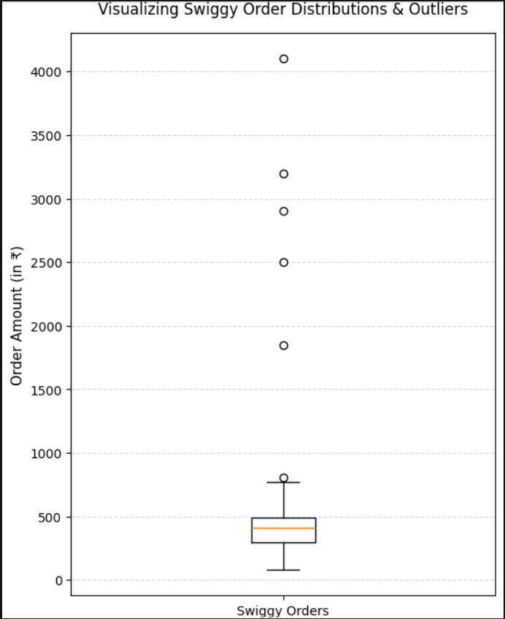

- Apply winsorization to the 'transaction_amount' column in a Paytm transactions DataFrame to cap all values above the 95th percentile and below the 5th percentile, then display the updated column statistics.
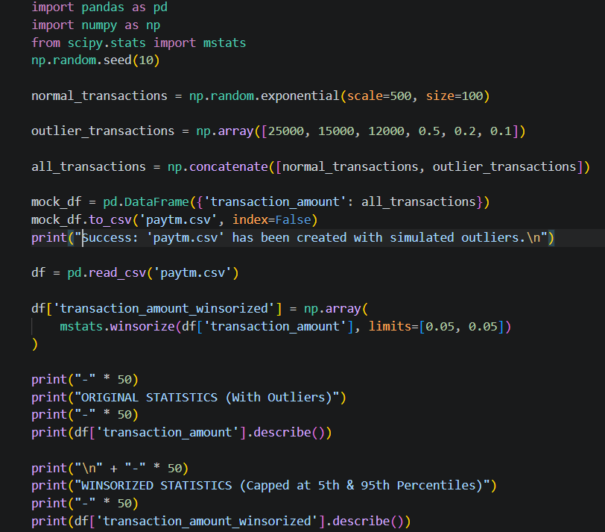
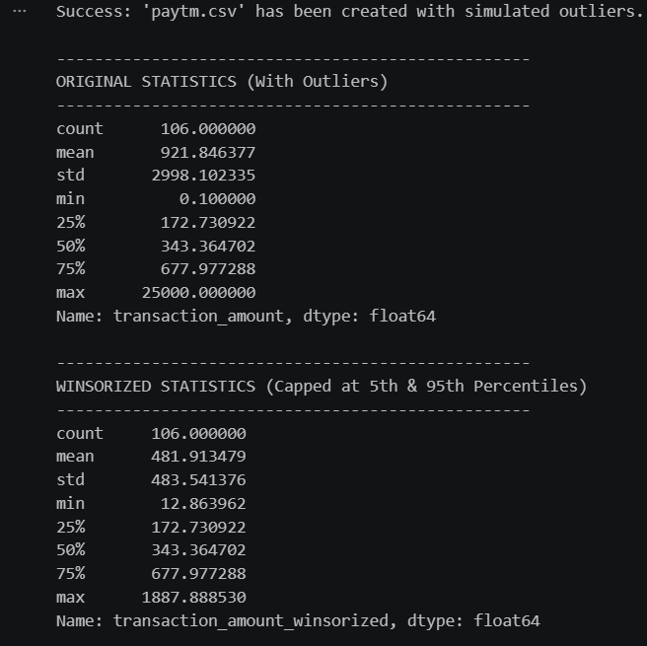

- You have a DataFrame of Flipkart product prices stored as strings with currency symbols (e.g., '₹1,299'). Convert this column to numeric type using pandas, ensuring all non-numeric characters are removed. Use str.replace() and astype().

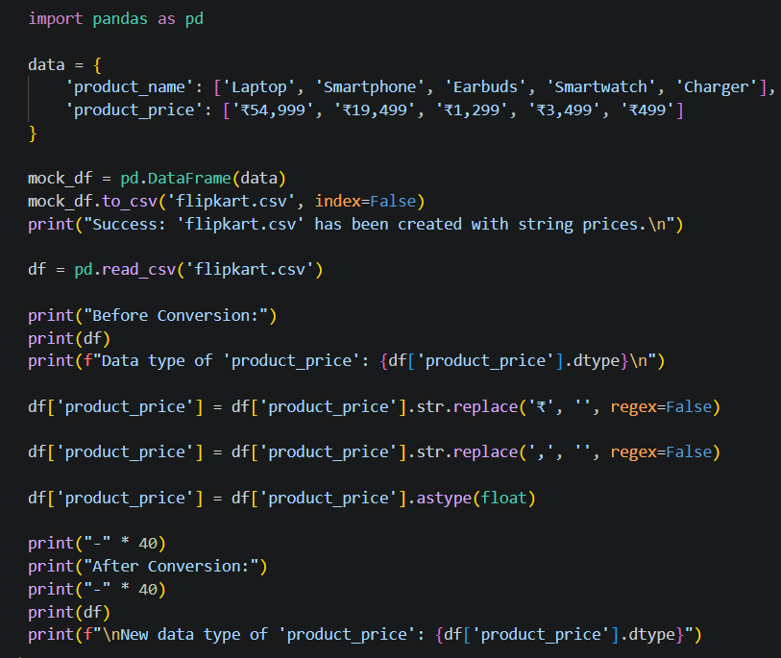
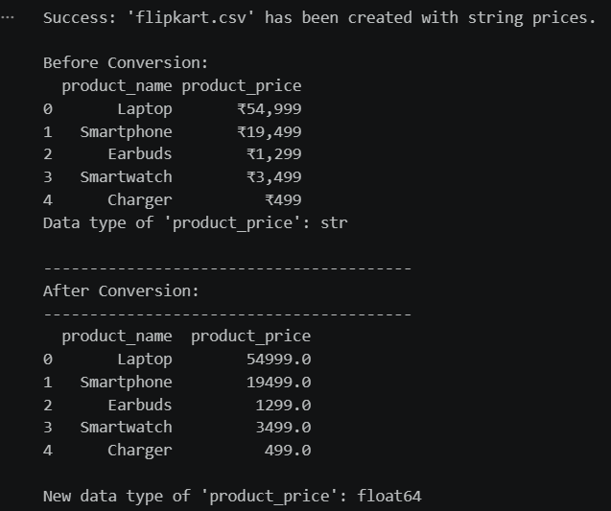

- Fix the following code snippet where the 'is_premium' column in a Spotify user DataFrame is a mix of boolean, string, and integer types. Convert the entire column to boolean type, treating 'True', 1, and 'yes' as True, and everything else as False.

